**USB Keyboard Interface for Apple IIe**

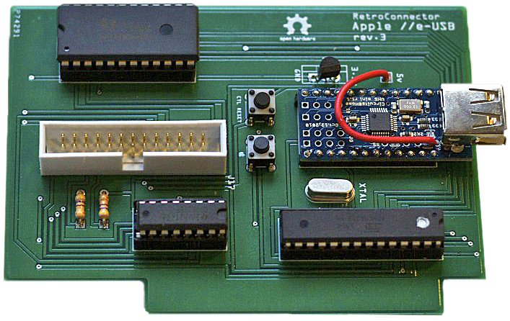

Thank you for purchasing this RetroConnector by Option8.

Please refer to this resource:

<https://github.com/option8/RetroConnector/tree/master/USB_IIe_Kbd>

If you have questions, please contact us via: <http://retroconnector.com/contact>

**NOTE**: Repeated insertion and removal of the board into a slot may scrape off the solder mask on the RetroConnector. This could expose copper fill beneath to the pins on the logic board. If your RetroConnector will be used in an Apple IIe slot, please check the board before inserting it for exposed copper. If any is visible, put tape or something else non-conductive on that part of the board before inserting it again.

**Will it work with an Apple USB keyboard?**Yes! Supporting firmware was updated September 30, 2013.

**Will it work with a wireless keyboard?**Yes. A few USB wireless keyboards were tested successfully, the type with a small dongle that attaches to a USB port.

**Can I hack or upgrade it?**Yes. All the software and hardware are open source. Everything needed is on GitHub. To update or modify the firmware on the ATMega328 chip, you also need: RetroConnector Firmware, Arduino Software, circuits@home Code Library, and an AVR Programmer.

**What Apple II models will this work with?**The RetroConnector USB Interface works in any model IIe. Testing with the IIgs continues via the keyboard port available on some logic boards, intended to be used as upgrades from IIe to IIgs. Some differences exist in the IIe and IIgs with the keyboard passing the startup self-test. Once those are solved, either an updated interface board will be released, or necessary modifications for the current revision will be published.

**How do I perform 'CTRL+Open-Apple+RESET' ?**There’s no Reset button on modern keyboards, so that's mapped to F12.  
The two Apple keys are mapped to ALT keys, so Left ALT is Open-Apple, Right ALT is Closed-Apple.  
Thus: Press F12 for 'CTRL+RESET' and Left ALT+F12 for 'CTRL+Open-Apple+RESET'

### Macros A few handy macros are included in the firmware, triggered by F-keys F1 through F5.

**F1**: Enter the Monitor  CALL -151

**F2**: WeaknessPoint Minus  8:20 35 FD 20 ED FD 4C 8 0 8G  
Martin Haye's minimal presentation interface (i.e. "Not PowerPoint")  
To clear the screen and begin typing, press ESC, then @.  
To navigate the screen, press ESC, then I,J,K, or M. Press ESC again to edit.

**F3**: WeaknessPoint Extended Version

**F4**: Calibrate Joysticks

10 print pdl(0) " " pdl(1) " " peek(-16287) " " peek(-16286) : goto 10  
Center on your joystick should read approximately 127 127.  
The third and fourth numbers are the joystick buttons.

Pressed, they should read higher than 128, and lower than 128 when not pressed.

**F5**: Graphics Test contributed by Dagen Brock

gr : for i=0 to 39 : color=i-(int(i/16)*16) : vlin 0,39 at i : next

### Hardware Buttons Two switches are on the RetroConnector board, labeled "Apple" and "CTRL+RESET"

# Pressing the "CTRL+RESET" switch sends CTRL+Reset and resets the system.

# Holding the "Apple" switch while pressing "CTRL+RESET" reboots the computer.

### Special Thanks To Fritzing.org for their excellent circuit layout software and the Fritzing Fab prototyping service. David Schmidt (of ADTPro fame) for early testing, debugging and advice.

### Brian Wiser for editing and enhancing this manual.